CHAPTER 27
MAGNETIC FIELD AND MAGNETIC FORCES
Discussion Questions
Q27.1 There is no force when and 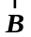 are parallel, so if the charge moves along a field line there will be no force on the charge.

Q27.2 The direction of the force depends not only on the direction of the magnetic field but also on the direction of the velocity of the particle. Two particles with different velocities at the same point will have forces in different directions so this definition of the direction of won’t be unique.

Q27.3 No, your left hand will give the opposite direction for the force.

Q27.4 No. For example, if the magnetic field lines are straight lines a charged particle initially moving along a field line will experience no magnetic force and will continue moving parallel to the field lines.

Q27.5 No. If the initial velocity is perpendicular to the magnetic field the particle will travel in a semicircle but will then exit the field again.
Q27.6 The magnetic force doesn’t change the speed of the particle but changes the direction of the velocity. Any centrifugal force in circular motion behaves in this way, for example the tension in a string when an object attached at its end swings back and forth.

Q27.7 Yes. The net force must be zero. An electric field would produce a net unbalanced force. No. The net force must be zero so there must be no magnetic force on the particle. But there could still be a magnetic field parallel to the velocity of the particle.

Q27.8 If the current loop is pivoted about a vertical diameter, the earth’s magnetic field will provide a torque that aligns the normal to the loop with the earth’s field. The earth’s magnetic field points toward the north geographic pole. The right-hand rule determines the direction of of the loop, as illustrated in Fig.27.32. When of the loop is in the direction of the earth’s field the loop is in a position of stable equilibrium. The loop can determine the direction of the earth’s field.

Q27.9 Find the orientation of the wire for which there is no force; the magnetic field is parallel to this direction. Then rotate the wire 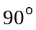 so it is perpendicular to the field. The two possible directions of give forces in opposite directions so observation of the direction of this force determines the direction of .

Q27.10 The magnetic field must be perpendicular to the plane of the loop. The current must travel around the loop in a direction so that the magnetic force on the current at each point is radially outward, as shown in the two sketches in Fig. DQ27.10.

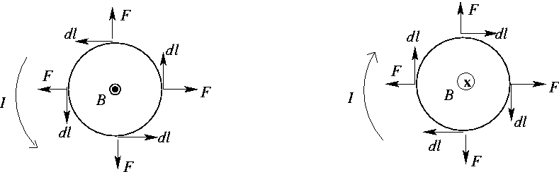

Figure DQ27.10

Q27.11 Assume the charges are moving from left to right in the plane of the page when they enter the magnetic field region. (a) A semicircular path in the counterclockwise direction, with radius 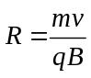. (b) A semicircular path in the counterclockwise direction, with radius 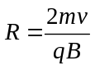.
(c) A semicircular path in the clockwise direction, with radius 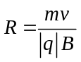. (d) There would be no force on the particle and it would travel in a straight line.

Q27.12 The direction of the force is given by the right-hand rule that is illustrated in Fig.27.7. If is parallel or antiparallel to 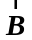, then the force is zero. 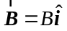.
a: Force is in the 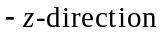. 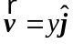. 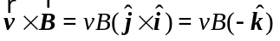.
b: Force is in 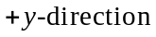. 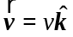. 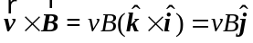.
c: Force is zero. 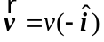. 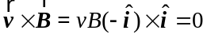.
d: Force is in 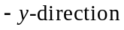. 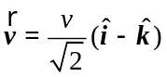. 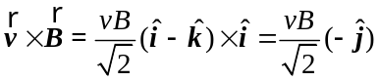.
e: The force has equal components in the 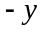 and directions.
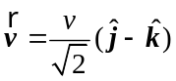. 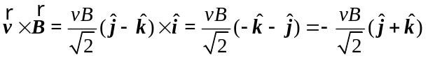.

Q27.13 The maximum force per unit length of the flagpole is  and for 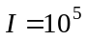 A and 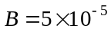 T (comparable to the earth’s field), 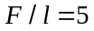 N. This is not enough force to bend a metal flagpole.

Q27.14 No. The magnetic force is always perpendicular to the velocity of the particle and therefore does no work. The magnetic force can’t change the kinetic energy of the particles. It can steer the particles but cannot increase their speeds.

Q27.15 There are two perpendicular motions. There is the movement of the charges in the wire of the loop, in the direction of the current. The magnetic force is perpendicular to this motion of the charges and doesn’t affect the magnitude of the drift velocity associated with the current. Then there is the rotation of the loop. The edges of the loop have a tangential velocity that is in the direction of the magnetic force and there is work done for this motion. The magnetic force can change the rotational speed of the loop.
Q27.16 In Fig.27.39 if the polarity of the battery is reversed the current in the rotor will be reversed and the torque will be in the opposite direction. The motor will turn in the opposite direction. But, as discussed in Section 27.8, in many motors the magnetic field is provided by electromagnets and the current for the electromagnets is produced by the same battery that provides the current through the rotor. So, when the polarity of the battery is reversed both the current in the rotor and the magnetic field reverse direction and the torque on the rotor is in the same direction as before the battery was reversed. The motion could be reversed if separate voltage sources were used for the current in the rotor and for the current in the electromagnets and if the polarity of only one of these sources was reversed.

Q27.17 Yes, if the current is carried equally by positive and negative charges.

Q27.18 The Hall-effect voltage is 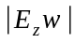, where is the width along the -axis of the strip. From Eq.(27.30) this gives 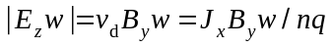. For semiconductors the concentration of current carrying charges is smaller than for a metal, so the Hall voltage is larger. For the same current density the drift velocity must be larger for a semiconductor since there are fewer current-carrying charges in a given volume. The larger drift velocity results in a larger magnetic force, and this larger force produces more charge separation between the edges of the strip.

